**Electronic Supplementary material**

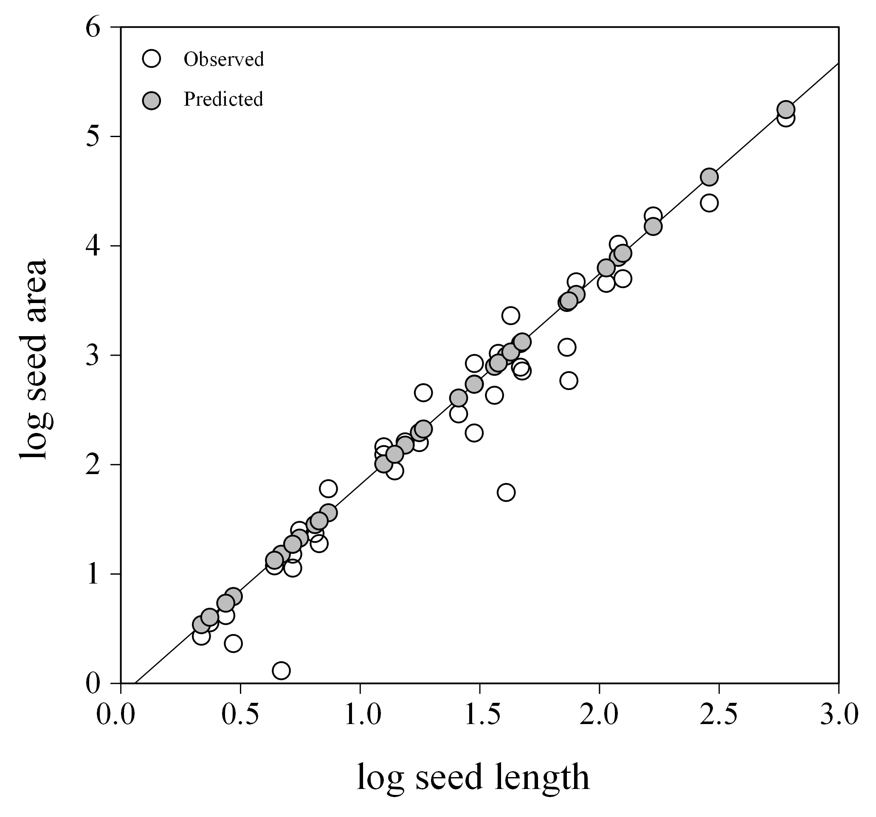

Figure S1. Relationship between seed length (mm) and seed surface area (length and width, mm2) for 36 taxa. Solid line is the result of OLS regression analysis. Open circles are observed values; closed circles are predicted values (based on regression parameters). Data are natural logarithm transformed.